Final Technical Report
Sean Schoch
University of the Cumberlands

Submitted to the University of the Cumberlands
in Partial Fulfillment of the Requirements of the Degree of
Master of Science in Artificial Intelligence
MSAI 699: Capstone Project Proposal
August 16th, 2026

Final Technical Report

Introduction
Crisis-related social media can provide useful public reports during disasters, but it also creates a large stream of unrelated, emotional, duplicated, or non-actionable messages. Emergency managers and analysts need tools that can reduce noise without hiding information that may be useful for response. This capstone project developed a binary natural language processing classifier to identify whether an open-source crisis message is informative enough to be elevated for human review.
The intended use is decision support, not autonomous emergency response. A positive prediction means a message should be reviewed by a human analyst; a negative prediction should not be treated as proof that the message is irrelevant. This distinction shaped the entire project because false negatives are operationally more serious than false positives. A false positive increases reviewer workload, while a false negative may suppress a damage report, request for help, evacuation update, or other time-sensitive information.
The final project objective was to build a transparent performance baseline, experiment with model improvements, evaluate generalization across crisis events, and document a deployment strategy that respects real-world constraints, ethics, and reliability. The most important finding was that the strong random-test performance did not fully transfer to unseen crises, making event-level testing and human-in-the-loop policy central to the final recommendation.

Methodology
The working dataset contained 5,149 unique messages from five CrisisLexT26 events after duplicate texts were removed. The events were the 2012 Colorado wildfires, 2012 Costa Rica earthquake, 2013 Boston bombings, 2013 Alberta floods, and 2013 Singapore haze. Messages originally labeled Related and informative were mapped to the positive class. All other labels, including Not related, Not applicable, and Related - but not informative, were mapped to the negative class. This binary target matched the first operational triage question: should the message be elevated for review?
The baseline model used term frequency-inverse document frequency features and regularized logistic regression. TF-IDF was selected because it represents short social-media text efficiently, while logistic regression provides probability scores and interpretable coefficients. The baseline used unigrams and bigrams, balanced class weights, a fixed random seed, and an 80/20 stratified train-test split. This established a transparent benchmark before testing more complex feature engineering.
The optimization phase used GridSearchCV on the training partition to tune regularization strength, class weighting, and n-gram settings. Text normalization replaced URLs and usernames with generic tokens, removed retweet markers, and retained hashtag words. A hybrid model then combined tuned word features with character n-grams to capture spelling variation, abbreviations, hashtags, and partial word patterns. A threshold of 0.47 was selected from out-of-fold training predictions to improve F1 without using test labels.
Explainability was implemented with SHAP to inspect local and global feature contributions. The testing and debugging phase then moved beyond a random split by using leave-one-event-out cross-validation. In each fold, a model trained on four complete crisis events and tested on the fifth as an unseen crisis. This testing design was stricter and more realistic because messages from the same event could not appear in both training and validation data.

Results
The random test results showed that the baseline was strong and that feature engineering produced a modest but useful improvement. The hybrid model improved recall and ROC-AUC and reduced false negatives on the random test. A training-selected threshold further improved recall, although it increased false positives and reviewer workload.

Table 1. Random Test Performance by Model
Model | Accuracy | Precision | Recall | F1-score | ROC-AUC | False negatives
Baseline | 0.831 | 0.830 | 0.854 | 0.842 | 0.902 | 79
Tuned word | 0.826 | 0.813 | 0.869 | 0.840 | 0.900 | 71
Hybrid word + character | 0.833 | 0.817 | 0.880 | 0.847 | 0.914 | 65
At the default threshold, the hybrid model reduced false negatives from 79 to 65. At the 0.47 threshold selected from training cross-validation, false negatives declined further to 56 and recall increased to 0.897. This was operationally meaningful because it prevented additional informative messages from being missed. However, the improvement was not free: false positives increased from 95 in the original baseline to 117 under the optimized threshold.

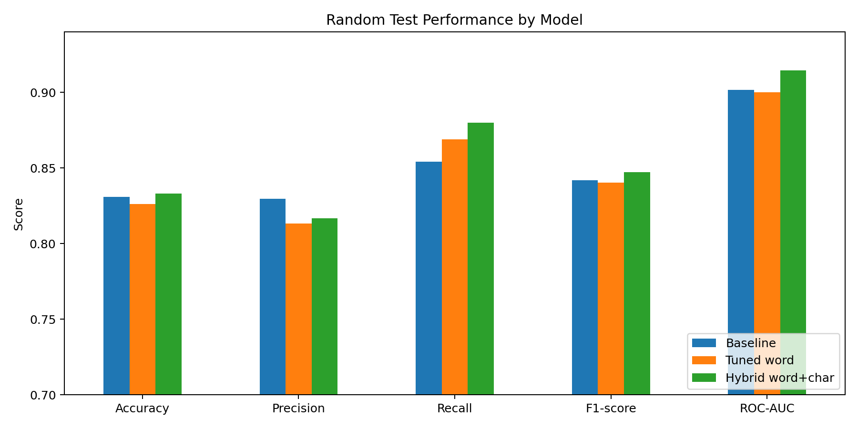
Figure 1. Random test performance comparison across the baseline, tuned word, and hybrid models.
Cross-event testing changed the interpretation of the model. When entire crisis events were held out, performance was lower and less stable than the random split suggested. The pooled cross-event results in Table 2 show that the hybrid model had a small F1 advantage over the baseline, but the baseline retained slightly better recall and fewer false negatives by itself. The best reliability result came from a policy that escalated a message if either model predicted it as informative.
Table 2. Pooled Leave-One-Event-Out Testing Results
Model | Accuracy | Precision | Recall | F1-score | ROC-AUC | False negatives | False positives | Review rate
Baseline 0.50 | 0.633 | 0.672 | 0.589 | 0.628 | 0.675 | 1113 | 779 | 0.462
Hybrid 0.47 | 0.644 | 0.691 | 0.586 | 0.634 | 0.708 | 1122 | 711 | 0.447
Either model escalates | 0.645 | 0.664 | 0.658 | 0.661 | 0.692 | 928 | 901 | 0.521

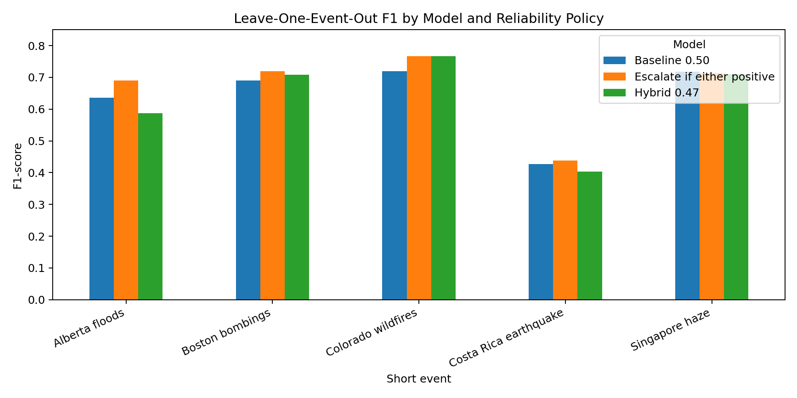
Figure 2. F1-score by held-out crisis event under leave-one-event-out testing.

Discussion
The project produced a model that is technically useful, but the strongest conclusion is not that one classifier should replace human review. Instead, the results show why crisis-report triage requires conservative reliability policy. The baseline random split achieved 0.831 accuracy and 0.842 F1, while the optimized hybrid model reached 0.847 F1 at the default threshold and 0.849 F1 with the 0.47 threshold. Those numbers indicate that the approach is feasible, but cross-event testing demonstrated that performance depends heavily on the crisis being evaluated.
The leave-one-event-out results exposed generalization as the central challenge. Some events transferred well, while others, especially the Costa Rica earthquake and Alberta floods, were much harder. SHAP and error analysis explained part of the problem: influential features included event-specific words such as Costa Rica, earthquake, fire, and PSI. Those features help within familiar crises but are not universal indicators of informativeness. This means the model can learn vocabulary associated with past events instead of learning only durable crisis-triage patterns.
Error analysis identified two recurring failure modes. First, event-specific or disaster-related words sometimes triggered false positives when the message was unrelated, not applicable, or related but not actually informative. Second, informative messages without URLs or numerical details were more likely to be missed. The false-negative rate for informative messages without URLs exceeded the rate for messages with URLs for both models. High-confidence missed cases also included Spanish-language updates and conversational descriptions of damage, suggesting that threshold tuning alone cannot solve all reliability problems.
A key debugging finding was that the baseline and hybrid models made complementary errors. The hybrid was correct on 375 messages that the baseline missed, while the baseline was correct on 316 messages that the hybrid missed. Among truly informative messages, the baseline caught 194 that the hybrid missed, and the hybrid caught 185 that the baseline missed. This motivated the tested guardrail policy: escalate a message for human review if either model predicts it as informative. That policy increased pooled cross-event recall from 0.589 for the baseline and 0.586 for the hybrid to 0.658, reducing false negatives from 1,113 and 1,122 to 928. The trade-off was a higher review rate, from about 46% for the baseline to 52%. In a crisis triage setting, this additional review burden is more acceptable than suppressing useful reports.

Ethical and Deployment Considerations
The ethical issue most directly connected to model performance is unequal reliability across crisis events. If a model performs well for one disaster type but poorly for another, it could cause some communities or situations to receive less consistent attention. This concern is especially important because the data are based on public social-media messages, where access, language, vocabulary, and posting behavior differ across populations. The model should therefore be evaluated by crisis event, language, and message characteristics before any operational use.
The recommended deployment approach is a cloud-hosted FastAPI service that returns the predicted class, probability, model version, threshold policy, and review recommendation. The service should log only the minimum information needed for audit and debugging, avoid unnecessary personal data retention, and include authentication, input validation, rate limiting, monitoring, and rollback capability. A local edge package could be maintained for low-connectivity environments, but the cloud deployment is more practical for centralized version control and monitoring.
The final system should not automatically discard messages. Instead, it should operate as a prioritization layer that routes likely informative and borderline messages to human reviewers. Probability thresholds should be configurable policy parameters approved by stakeholders rather than hidden technical constants. Event-level dashboards should monitor recall proxies, message volume, review rate, drift indicators, and reviewer corrections so the system can be paused or rolled back if performance degrades.

Future Work
Future work should expand the dataset beyond five events and include more diverse crisis types, languages, geographic regions, and communication styles. Nested group-based validation should be used as the standard evaluation method so that model choices are not based on event leakage from random splits. The weakest event-level results should be reviewed manually to determine whether failures are driven by language, event vocabulary, label ambiguity, or missing contextual information.
The next modeling step should compare the current TF-IDF/logistic-regression family with a transformer model such as DistilBERT. A transformer may capture more context, but it must be evaluated against the same event-level tests and deployment constraints. If the transformer improves recall on unseen events without creating unacceptable latency, cost, or explainability trade-offs, it could become the leading candidate. Otherwise, the transparent baseline and hybrid models remain more defensible for a human-in-the-loop workflow.
The project should also incorporate reviewer feedback. In production, human decisions could be used to identify recurring false positives, missed informative posts, and new crisis vocabulary. However, any feedback loop should be governed carefully to avoid reinforcing biased reviewer behavior or overfitting to one active crisis. The final technical recommendation is therefore cautious: the project is feasible as a triage support tool, but it requires continuous auditing, broader validation, and clear human accountability before operational deployment.

References
Lundberg, S. M., & Lee, S.-I. (2017). A unified approach to interpreting model predictions. Advances in Neural Information Processing Systems, 30. https://arxiv.org/pdf/1705.07874
Olteanu, A., Vieweg, S., & Castillo, C. (2015). What to expect when the unexpected happens: Social media communications across crises. Proceedings of the 18th ACM Conference on Computer Supported Cooperative Work & Social Computing, 994-1009. https://doi.org/10.1145/2675133.2675242
Pedregosa, F., Varoquaux, G., Gramfort, A., Michel, V., Thirion, B., Grisel, O., Blondel, M., Prettenhofer, P., Weiss, R., Dubourg, V., Vanderplas, J., Passos, A., Cournapeau, D., Brucher, M., Perrot, M., & Duchesnay, E. (2011). Scikit-learn: Machine learning in Python. Journal of Machine Learning Research, 12, 2825-2830. https://dl.acm.org/doi/10.5555/1953048.2078195
National Institute of Standards and Technology. (2023). Artificial Intelligence Risk Management Framework (AI RMF 1.0). U.S. Department of Commerce. https://nvlpubs.nist.gov/nistpubs/ai/NIST.AI.100-1.pdf

